Editing Vi Editor
• vi (Visual Editor) is one of the most widely used text editors in Linux/Unix systems.
• It’s terminal-based (runs in the shell) and very powerful once you know the commands.
________________________________________

Modes in vi
vi mainly has three modes:
1. Command Mode (default)
• Used for navigation, deleting, copying, saving, quitting, etc.
• Keys are interpreted as commands.
• Example: dd deletes a line.
2. Insert Mode
• Used to actually type and edit text.
• Enter insert mode from command mode by pressing:
- i → insert at cursor
- a → append after cursor
- o → open a new line below
• Press Esc to return to Command Mode.
3. Execution Mode

Command Mode
• Default mode when you open a file with vi filename.
• In this mode, every key you press is treated as a command, not as text input.
• You can navigate, delete, copy, paste, search, and run commands, but you cannot type text directly.
• To type/edit text, you must switch to Insert Mode.
________________________________________

How to Enter Command Mode
• When you open a file in vi, you are already in Command Mode.
• If you’re not sure, press Esc → this always brings you back to Command Mode
Common Command Mode Actions
Action Command (in Command Mode)
Delete current line Dd
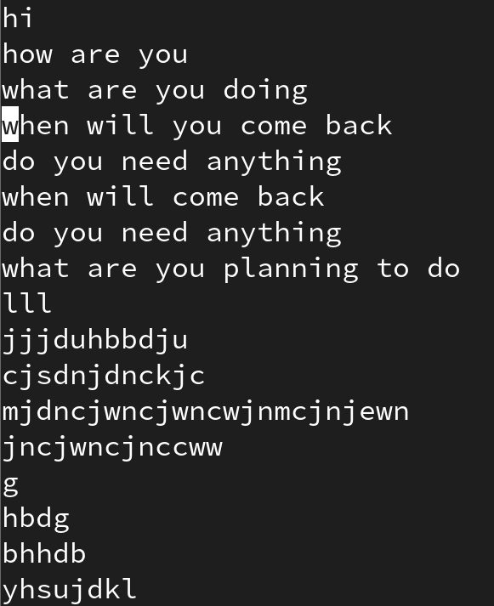
Delete word Dw
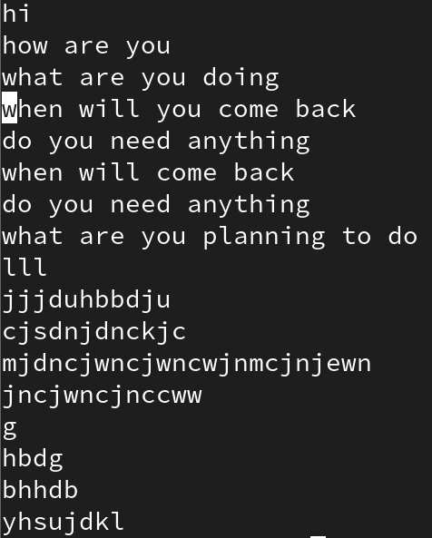
Copy line Yy
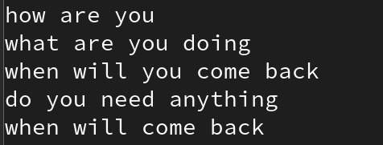
Paste P
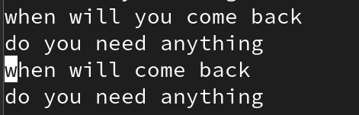
Undo last change U
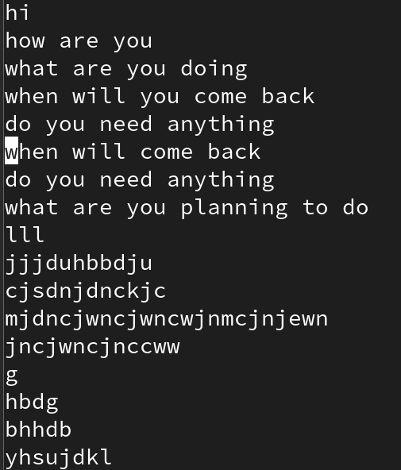
Redo Ctrl+r
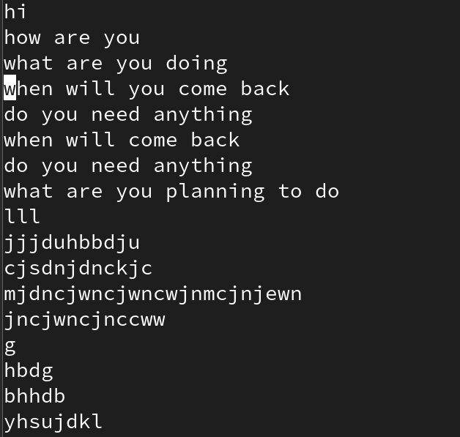
Search for a word /word
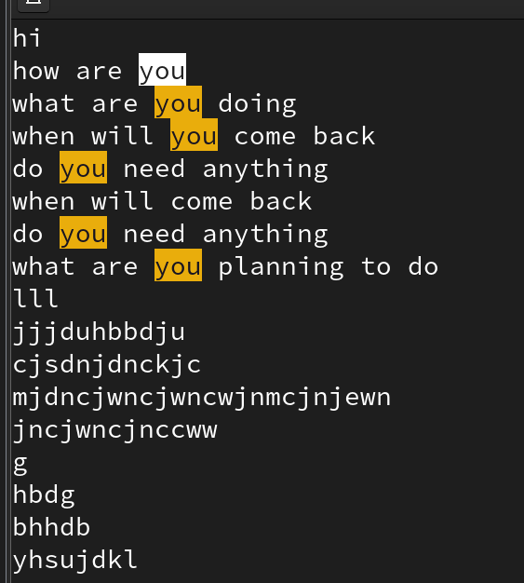
Replace first occurrence in line :s/old/new
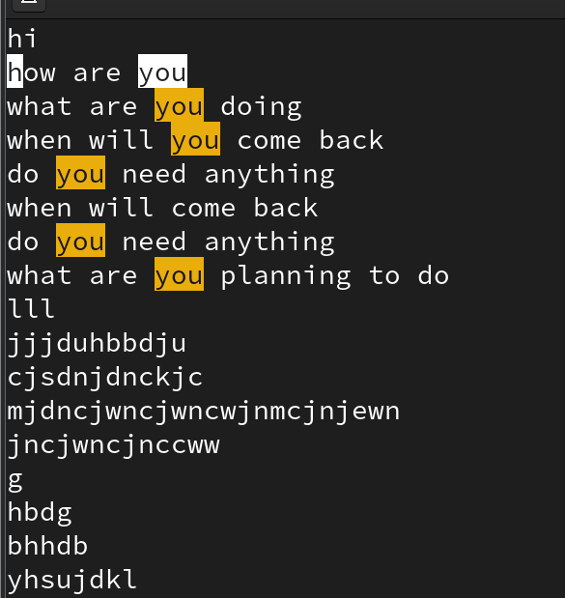
Replace all occurrences in line :s/old/new/g
Replace in whole file :%s/old/new
Save :shift +zz or ZZ
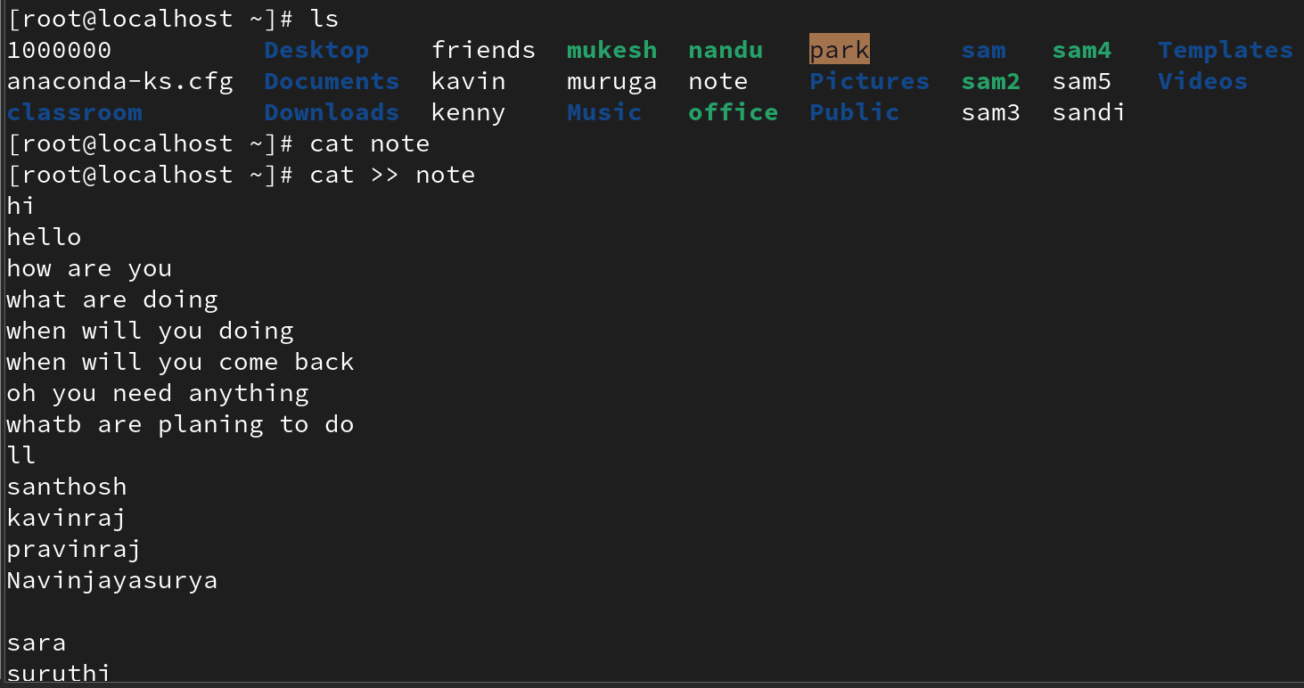
Quit :q
Save & Quit :wq
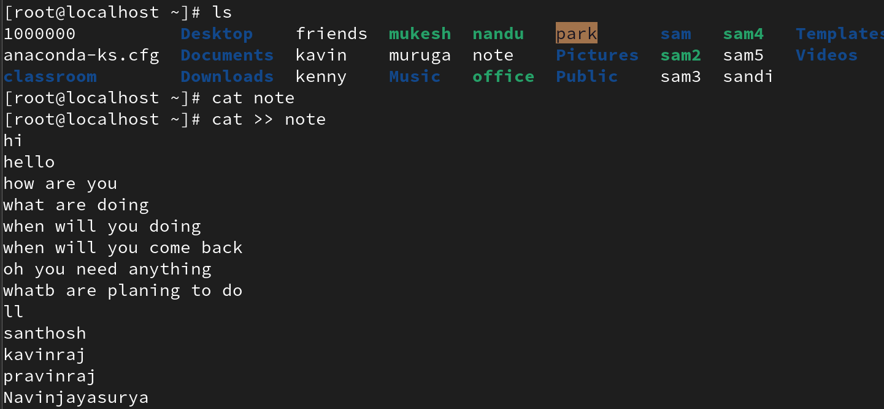

Insert Mode
🔹 What is Insert Mode?
• Insert Mode is where you actually type and edit text in vi.
• When you open a file, you start in Command Mode (where keys are commands).
• To type normal text, you must switch into Insert Mode.
• Once in Insert Mode, the keys you press are inserted into the file (just like in a normal editor).

How to Enter Insert Mode
Command Action
i Insert before the cursor
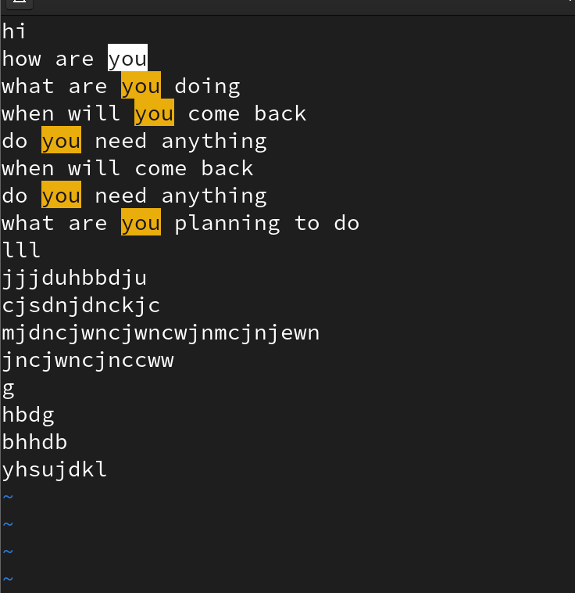
I Insert at the beginning of the current line
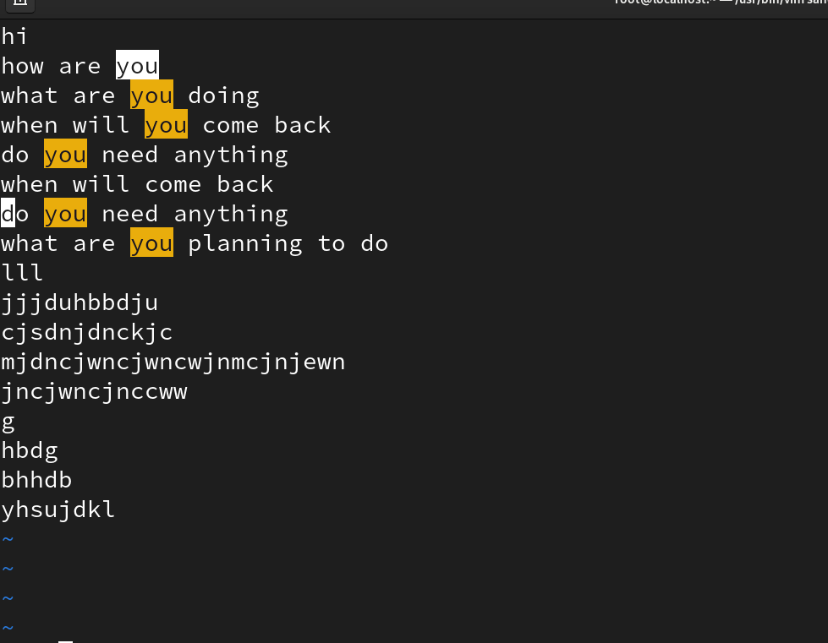
a Append (insert after the cursor).
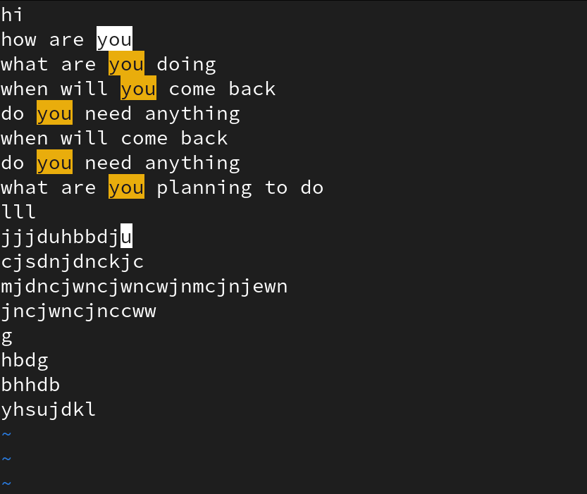
A Append at the end of the current line.
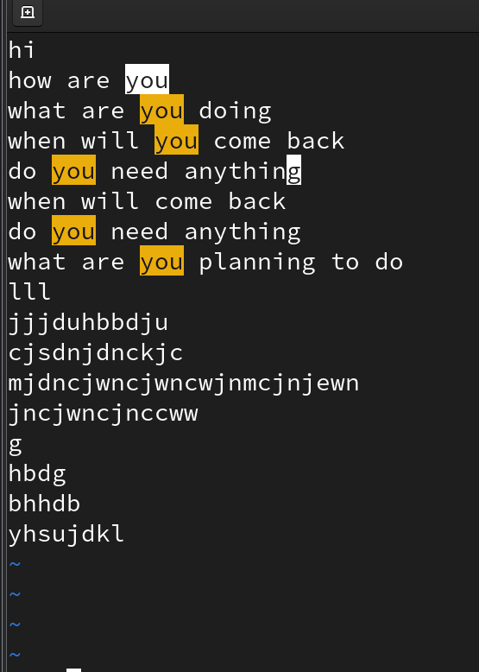
O Open a new line below the current line and enter insert mode.
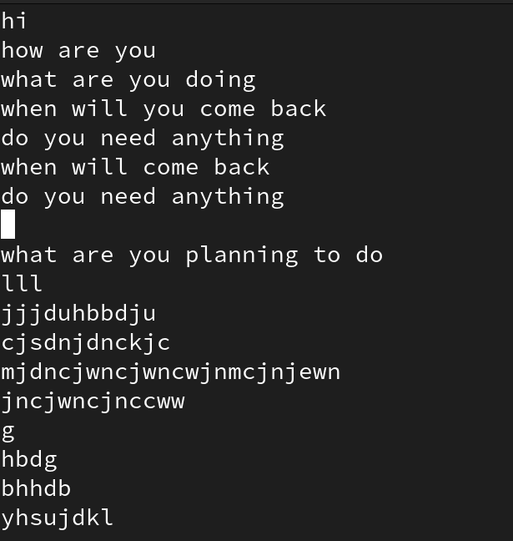
O Open a new line above the current line and enter insert mode.
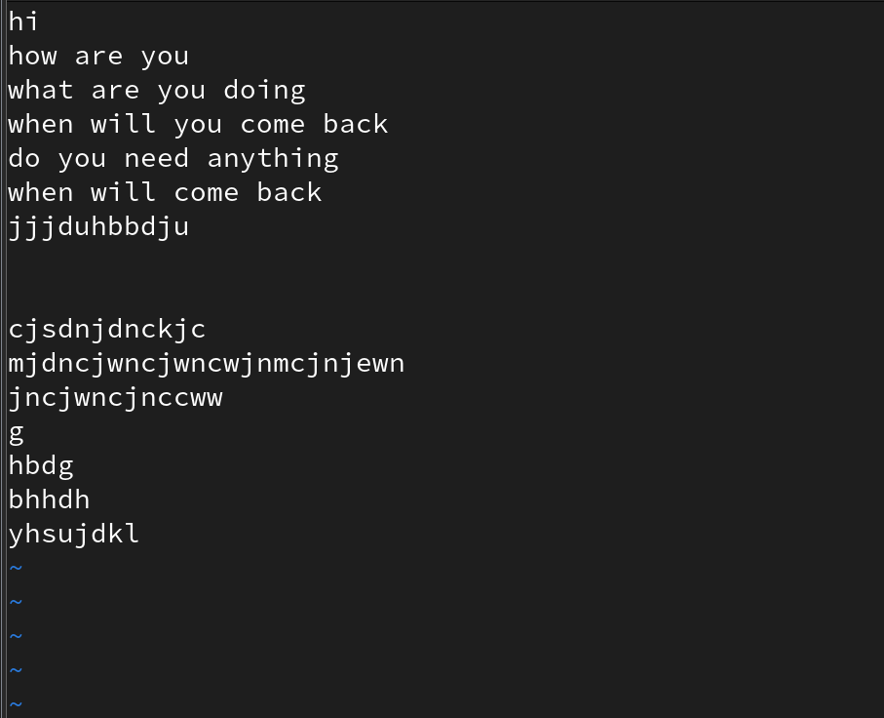
After editing, press Esc to go back to command mode.

Execution Mode
Ex Mode is accessed by typing : in command mode.

Ex Mode Commands in Vim
Command | Meaning / Function

